**Step 1: Connecting to a Data Source :**

* **Creating a new DSN :**
  + Start 🡪 Control Panel 🡪 Administration Tools 🡪 Data Sources

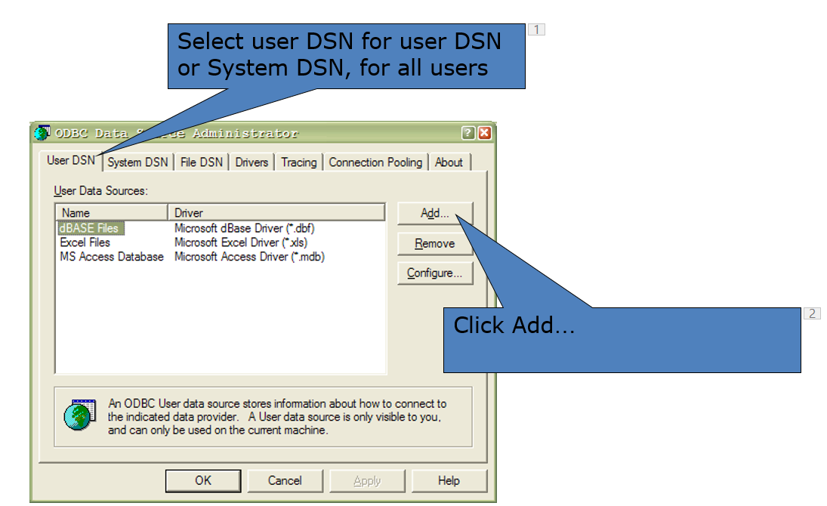

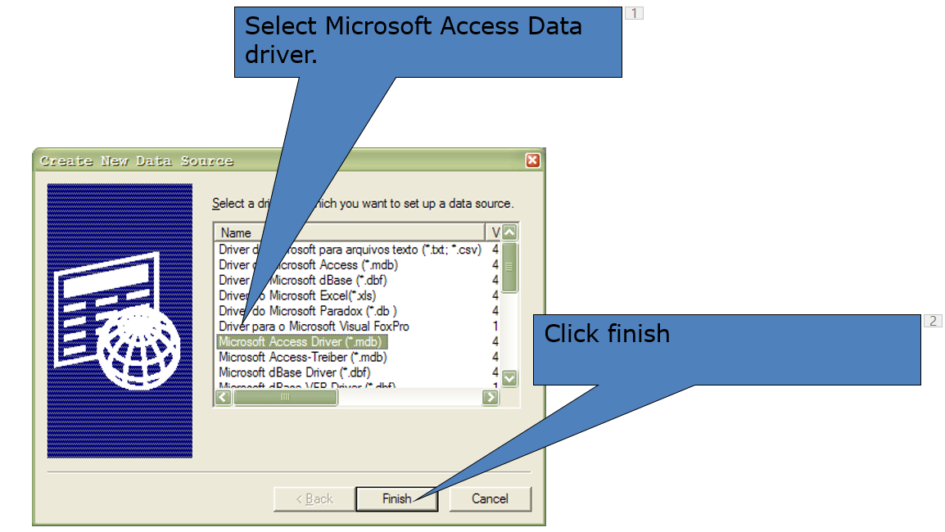

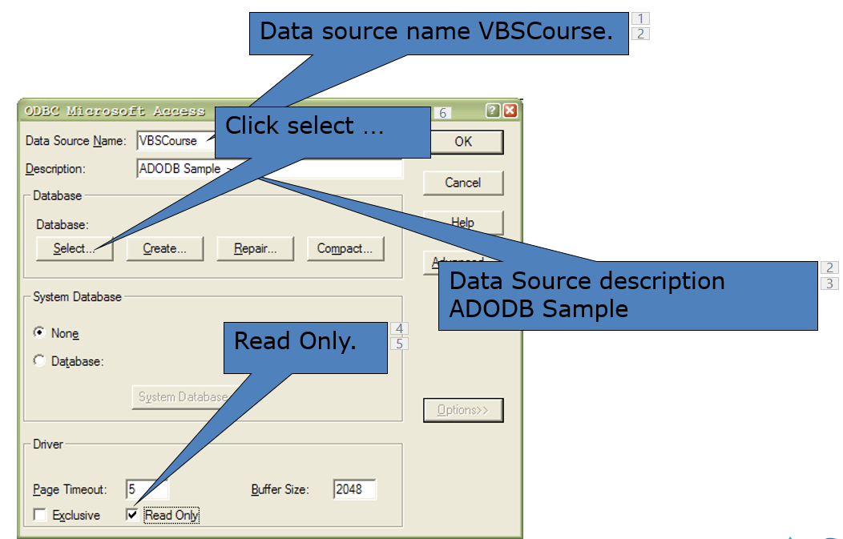

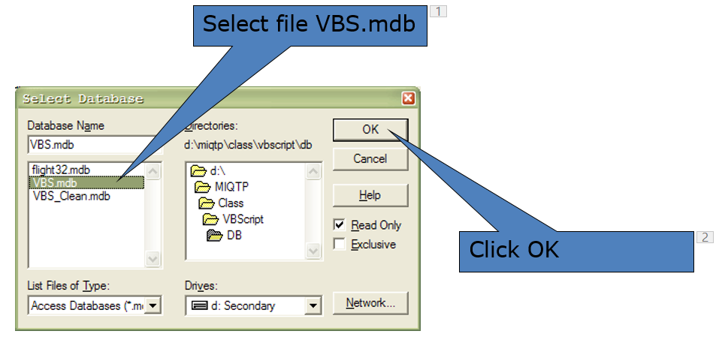

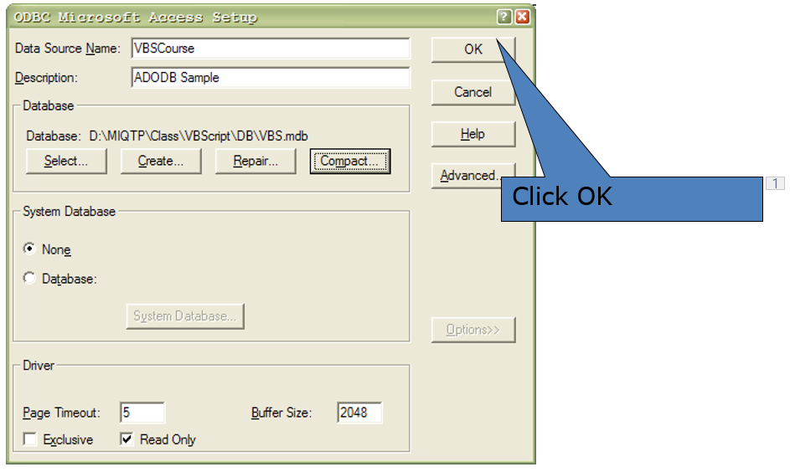

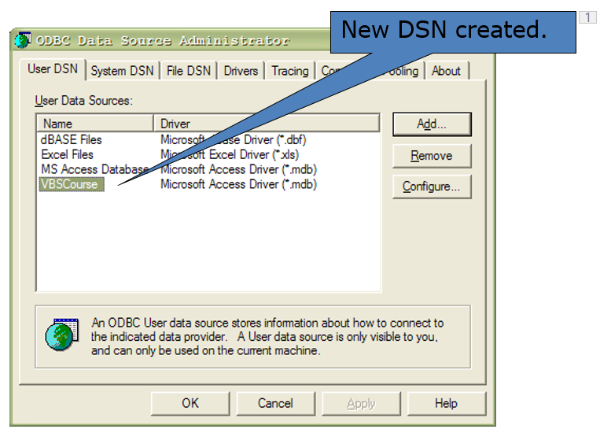

**Step 2: Connecting to a Database :**

* **Using the DSN :**

**Set** objConn = **CreateObject** (“ADODB.Connection”)

objConn.**Open** “VBSCourse”

**(or)**

* **Using a connection string**

**Set** objConn = **CreateObject** (“ADODB.Connection”)

objConn.**ConnectionString** = “Provider=Microsoft.Jet.OLEDB.4.0;Data Source=C:\Class\VBScript\DB\VBS.mdb”

objConn.**Open**

**Step 3: Checking the Connection**

* **After we activate the method open to te connection, we must check if the connection was succesfull**

Const adStateOpen = 1

If Not objConn.State = adStateOpen Then Exit.

**Step 4: using the recordset and Querying the Database**

strSQL = “Select * From Employes Where State=‘NY’”

Set objRst = objConn.Execute(strSQL)

‘instead of the above one line we can also write the below two lines

‘Set objRst = CreateObject(“ADODB.Recordset”)

‘objRst.Open strSQL, objConn

While Not objRst.EOF

iCounter = iCounter + 1

strRep = “First Name : “ & objRst(“EmpFirstName”).Value & vbCr

strRep = strRep & “Last Name : “ & objRst(“EmpLastName”).Value & vbCr

strRep = strRep & “Address: “ & objRst(“EmpAddress”).Value & vbCr

MsgBox strRep,0,”Employee “ & iCounter

objRst.MoveNext

Loop

* **Write an interactive program to navigate in a recordset.**
  + **Build a new DNS connection.**
  + **An input box should ask the user**
    - **1 – Go to the first record.**
    - **2 – Go to the next record.**
    - **3 – Go to the previous record.**
    - **4 – Go to the last record.**
  + **Be aware of EOF and BOF**
  + **Use the table ‘Employees’ in the Database.**
  + **Error handling.**